AWS SQS
Task Title
Create and Validate Amazon SQS Standard Queue
Objective
Validate your Amazon SQS Standard Queue by sending, receiving, and deleting test messages in the AWS Console to confirm end-to-end message flow and monitoring.
Prerequisites
- AWS account with access to Amazon SQS
- IAM user/role with permissions: sqs:CreateQueue, sqs:SendMessage, sqs:ReceiveMessage, sqs:DeleteMessage
- AWS Management Console or AWS CLI installed and configured
- Basic understanding of message producers and consumers
- (Optional) EC2/Lambda or local system to test sending and receiving messages

Step by Step Implementation:
Go to Amazon SQS in the AWS Console.
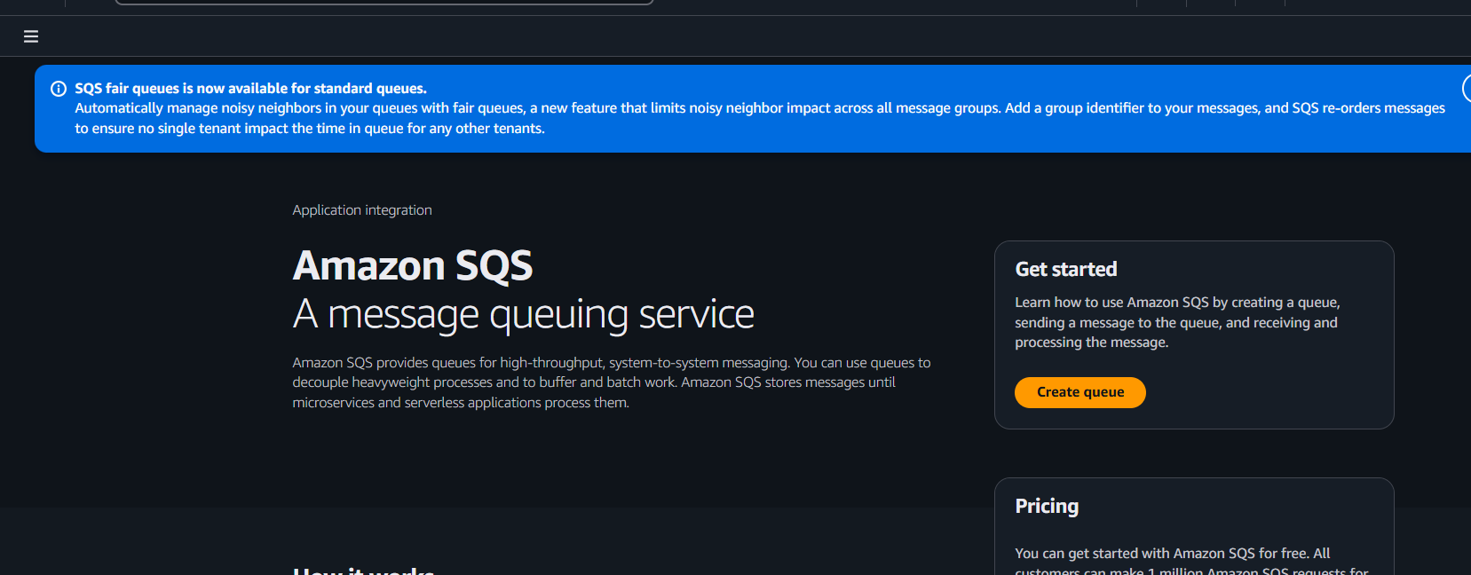
Click on create queue and select standard type and continue
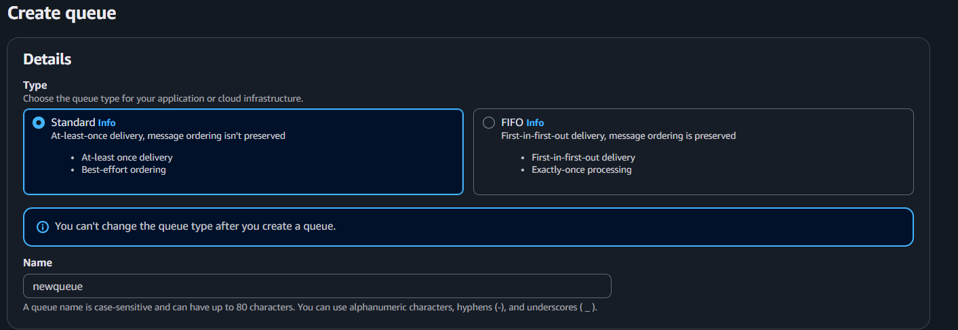

Keep the default configurations as it or you can edit
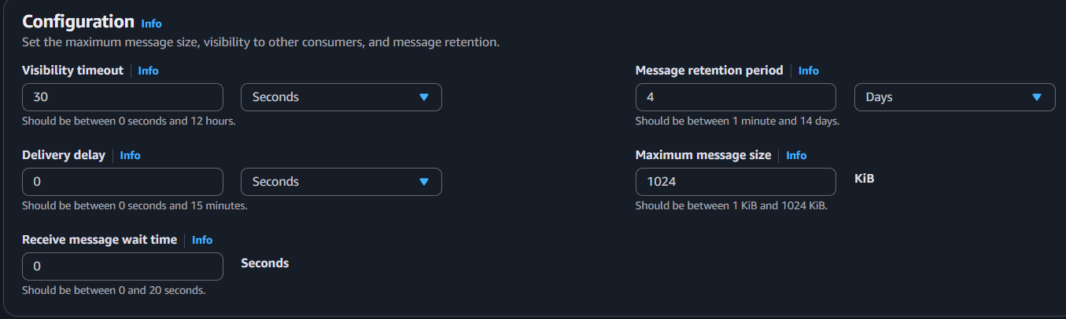
Select the encryption type either SSE or KMS
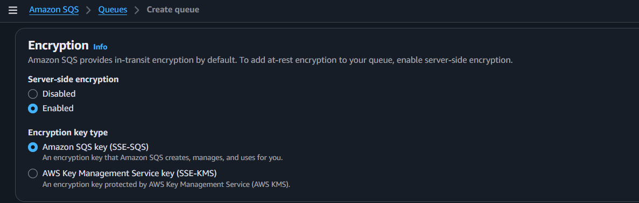
Select the Policy Type as basic or advanced
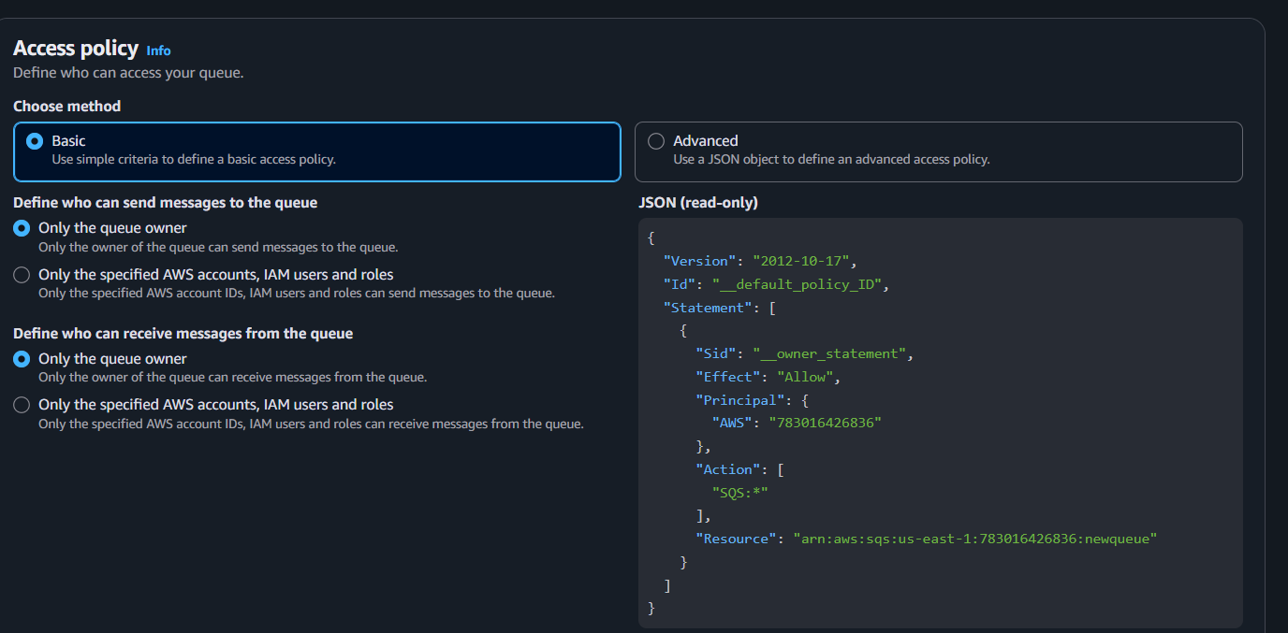

Then click on create queue
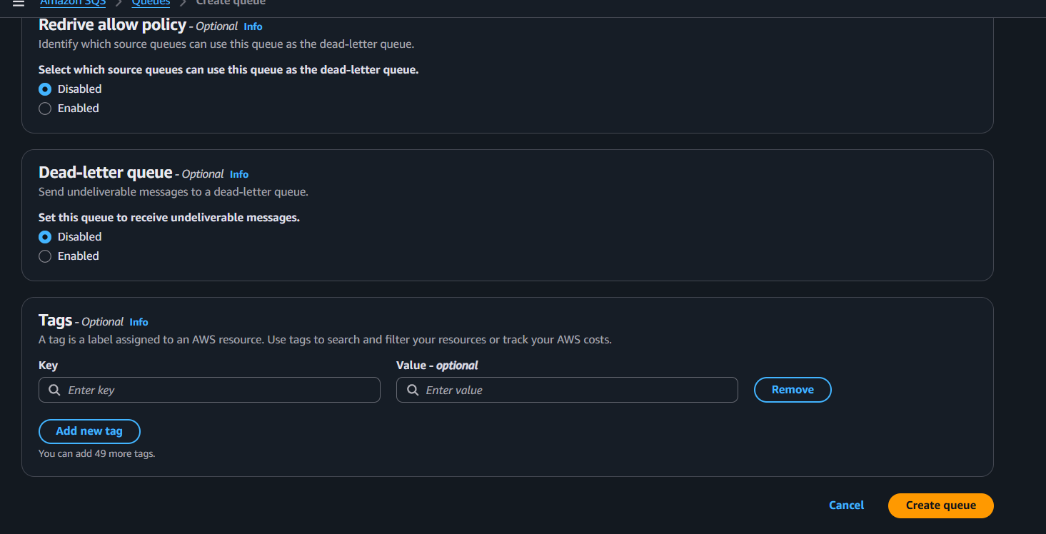
Queue has been created
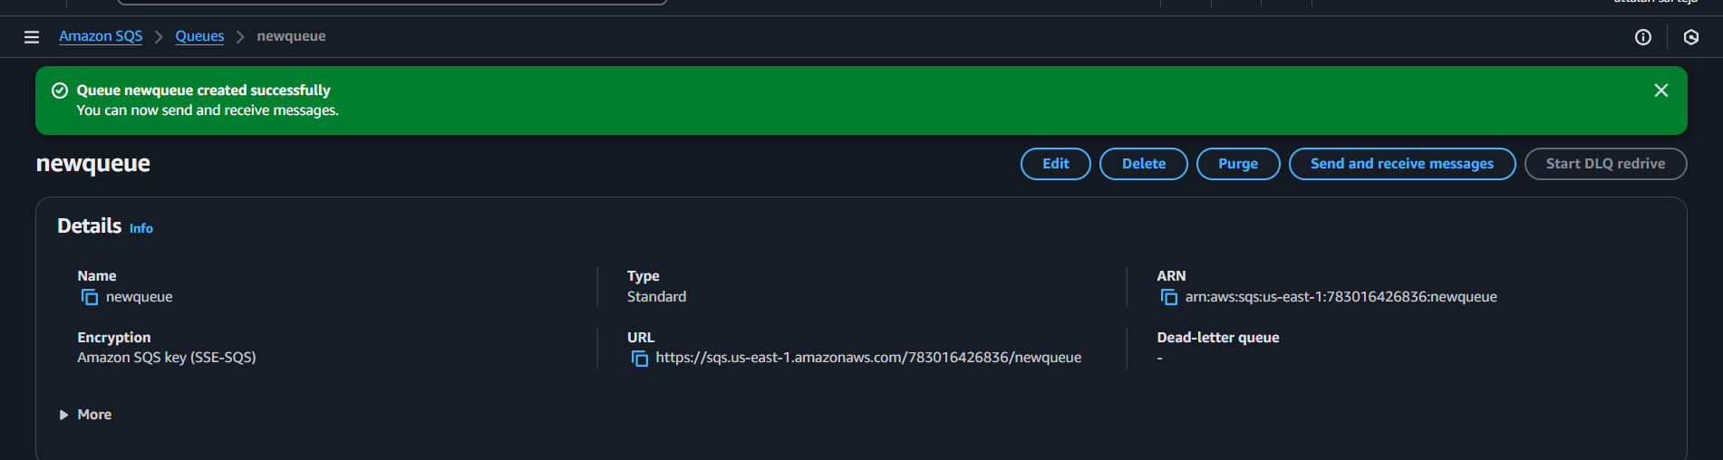
Click on send or receive messages and send a text message and click on send
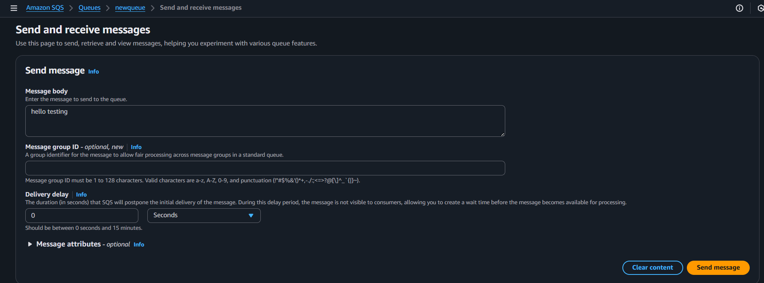

A pop up will be visible when you click on view message details
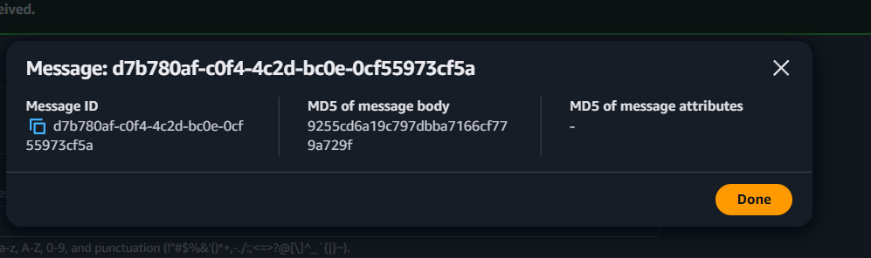
Click on POLL for messages to receive the messages and you can read them
You need to delete after reading that confirm your acknowledge
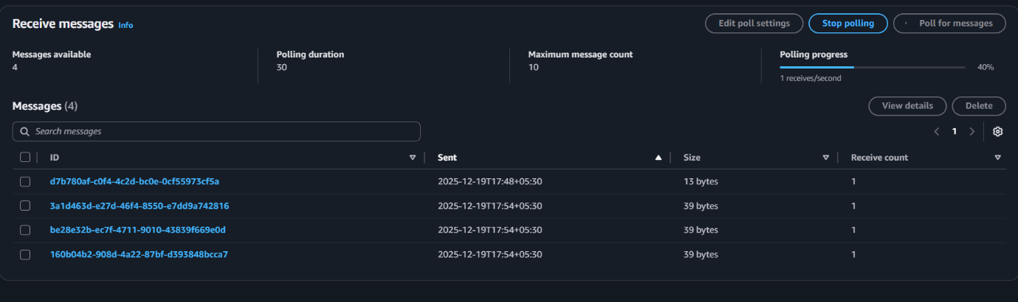
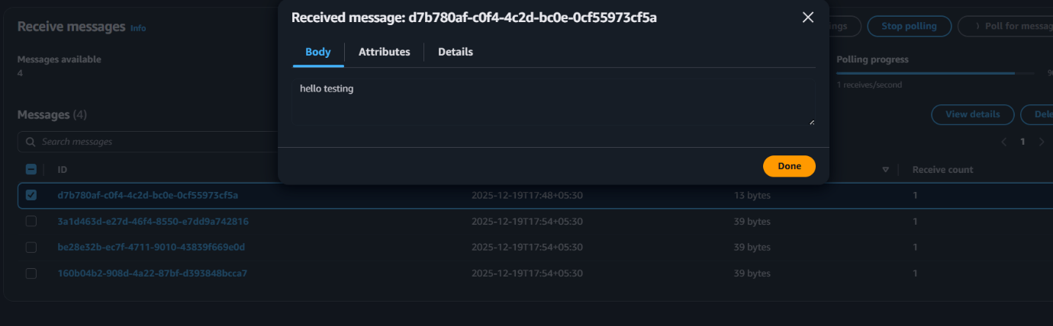
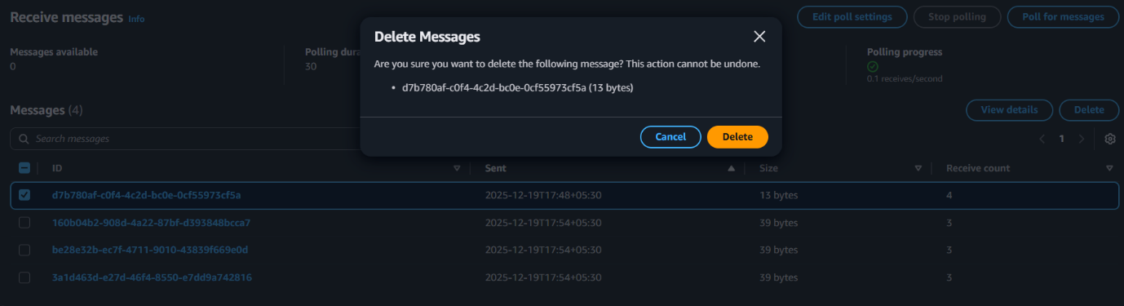
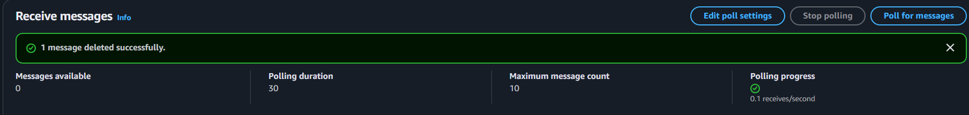
In the monitoring tab you can monitor the messages types
Like how many messages got and how many are in pending state etc
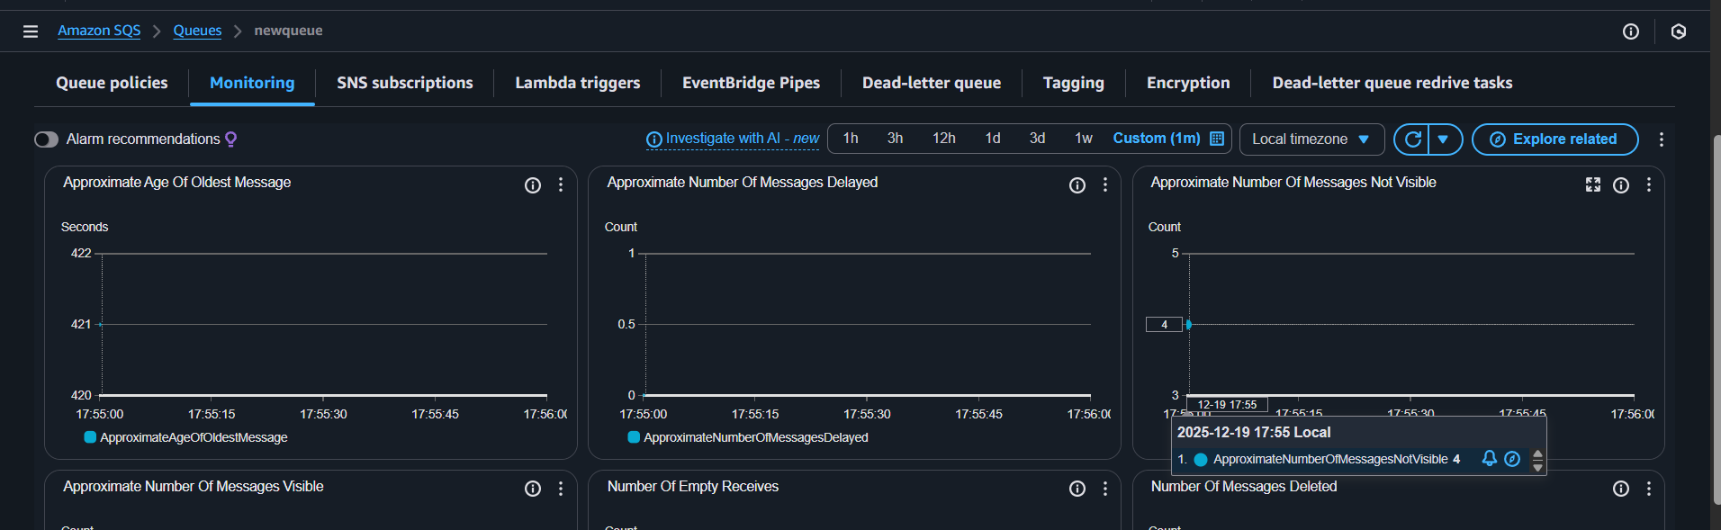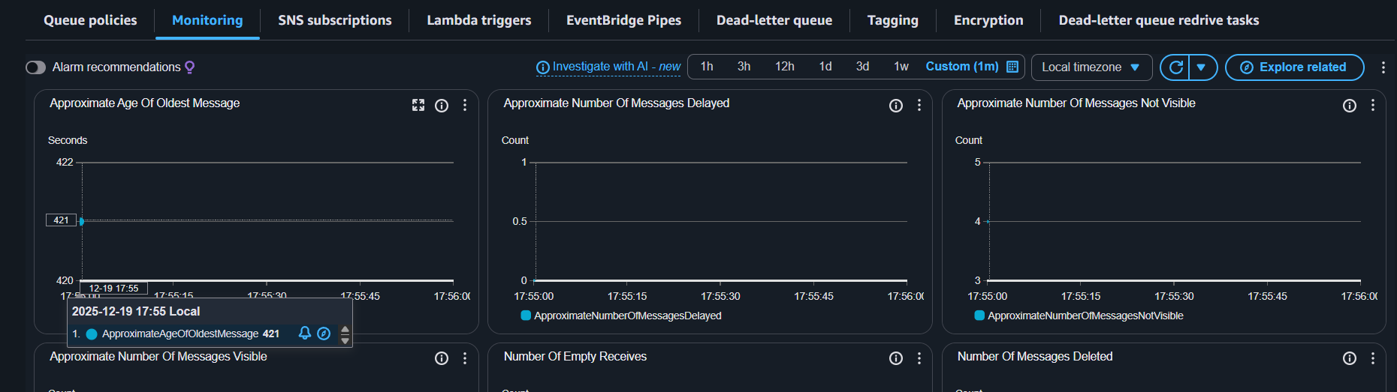

Conclusion
Amazon SQS Standard Queue enables reliable, highly scalable asynchronous messaging between distributed components. By creating and validating the queue, we ensure that producers and consumers can successfully exchange messages, helping to decouple services and improve application resilience and scalability.

